ТЕСТ
по выявлению артикуляционно-акустической дисграфии

Фамилия _____________________________ Имя ___________________________

1. Напиши названия картинок
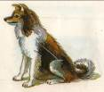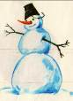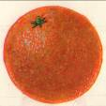
_________________ ___________________ ___________________

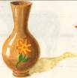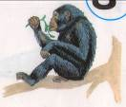
______________ ________________ ______________________

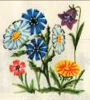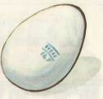
______________ ______________ _______________

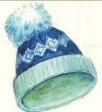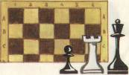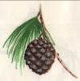
________________ ___________________ __________________

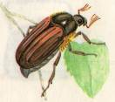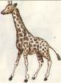
________________ _________________ ________________

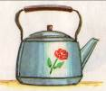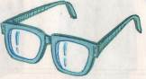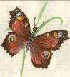
_______________ _______________ ___________________

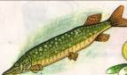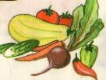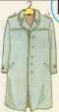
_____________ __________________ ____________

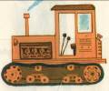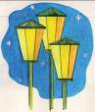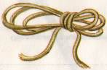
_______________ ______________ __________________

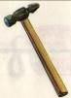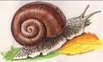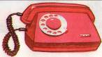
_____________ _______________ _____________________

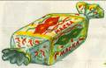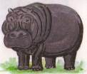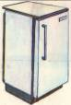
_________________ __________________ ____________________

2. Составь и запиши словосочетания

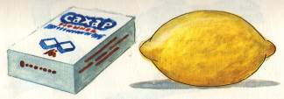
________________________________________________________________________________________________________________________________________________

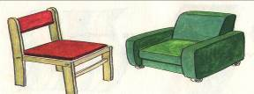
________________________________________________________________________________________________________________________________________________

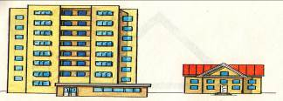
________________________________________________________________________________________________________________________________________________

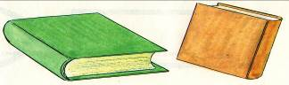
________________________________________________________________________________________________________________________________________________

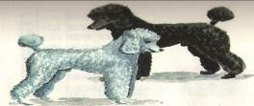
________________________________________________________________________________________________________________________________________________

3. Составь и запиши предложения

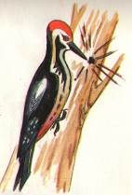
____________________________________________________________________________________________________________________________________________________________________________________________________________________________________________________________________________________

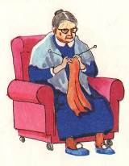
________________________________________________________________________________________________________________________________________________________________________________________________________________________________________________________________________________________________

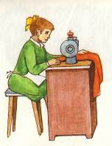
____________________________________________________________________________________________________________________________________________________________________________________________________________________________________________________________________________________

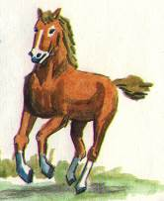
____________________________________________________________________________________________________________________________________________________________________________________________________________________________________________________________________________________________________________________

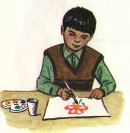
____________________________________________________________________________________________________________________________________________________________________________________________________________________________________________________________

4. Составь и запиши рассказ

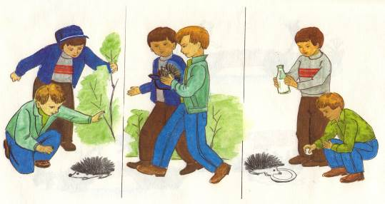

____________________________________

________________________________________________________________________________________________________________________________________________________________________________________________________________________________________________________________________________________________________________________________________________________________________________________________________________________________________________________________________________________________________________________________________________________________________________________________________________________________________________________________________________________________________________________________________________________________________________________________________________________________________________________________________________________________________________________________________________________________________________________________________________________________________________________________________________________________________________________________________________________________________________________________

С | С' | З | З' | Ц | Ш | Ж | Ч | Щ | Р | Р' | Л | Л' | К | К' | Г | Г' | Х | Х'

